**WEEK 10 – PYTHON - MANIPULATING DATA - EXERCISES**

1. Prompt the user to enter a department name ‘IT’ and location ‘OXFORD’ and insert a new row into the department table.

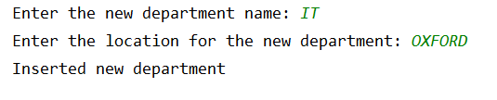

From SQLite, run the query SELECT * FROM dept; and check that the new department has been inserted correctly with a deptno value.

2. Prompt the user to enter a department name and a new location. Check if the entered department exists and if not, print an error message. If it does exist, update the row for that department to set the new location. Ensure that the new location is inserted into the database in uppercase even if its entered in lowercase. Test it with the IT department that you’ve just created in question 1 and a department name that doesn’t exist.

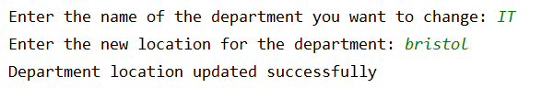

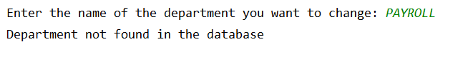

3. Prompt the user to enter a department name. If the department entered doesn’t exist, display an error message and if the department has employees, display the error ‘Cannot delete department as it has employees’. Ensure you include the following command before issuing any other SQL commands to enable foreign key constraints:

cursor.execute(**"PRAGMA foreign_keys=ON"**)

Test it for the IT department you created in question 1 and for a department that’s has employees e.g. SALES.

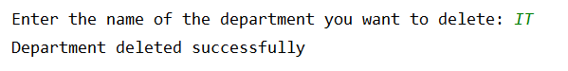

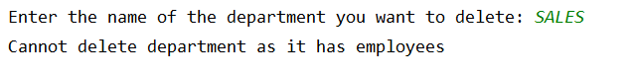

4. Prompt the user to enter a product id and display the current price for that product or display an error if the product id is not found in the database. If a valid product id has been entered, prompt the user to enter a new price, update the current price row for this product and set the enddate to today’s date. Then insert a new row for the new price with a startdate of today’s date and a min price £3.00 less than the new price entered.

To get today’s date, you will need to put *import datetime* at the top of your script and use the following commands:

now = datetime.datetime.now()  
todays_date = now.strftime(**"%Y-%m-%d"**)

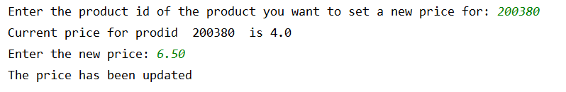

5. Get the user to enter the following for a new employee:

* + Employee name
  + Job
  + Manager name
  + Monthly salary
  + Name of their department

Get the empno corresponding to the manager name entered and the deptno for the department name entered. If both exist, then insert a new row into the emp table for the new employee setting hiredate to todays date. If either the manager name or department name entered are not found in the database, display an appropriate error.

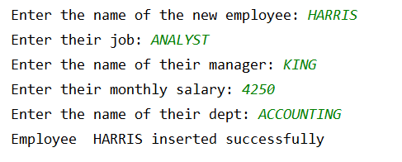

Do a SELECT * FROM emp; to check that the new employee record has been successfully inserted.